Lab 5 Session 2 Report

For this lab, we were told to find compare the value of y(t) by finding it two different ways. This lab is basically an application of the Fourier transform Convolution property. The FT Conv. Property states that convolution in the time domain is the same thing as multiplying in the frequency domain. We used this throughout the lab to compare y(t).

In the first problem we were asked to generate the two given signals in LabView and to add a control, D, that represents the time shift. The code that I used and a screenshot of the graph are below:

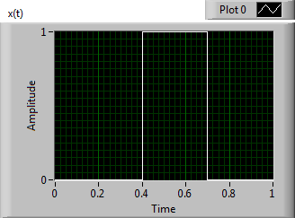 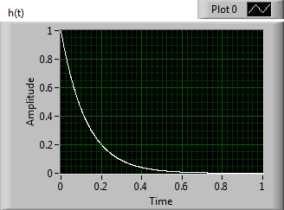

In the second problem we were asked to find y(t) by convolving x(t) and h(t) as well as plot y(t) on a graph. The code that I used and a screenshot of the graph are below:

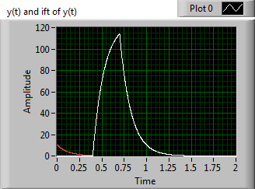

In the second problem we were asked to again find y(t) but this time we were go8ing to use a Fourier transform approach. The steps to doing this are simple: convert x(t) and h(t) into X(jw) and H(jw) and then apply the FT Conv. Property and multiply X(jw) and H(jw) to get Y(jw). After getting Y(jw), you can take it back into the time domain by doing the inverse Fourier transform of it.

1. The code that I used to plot the phase and magnitude of both X(jw) and H(jw) is below along with a screenshot of the graphs that were produced by the code:

y_f1 = (-fs/2):(fs/length(xt)):(fs/2)

xFT_mag = abs(xFT)

xFT_phase = angle(xFT)

hFT_mag = abs(hFT)

hFT_phase = angle(hFT)

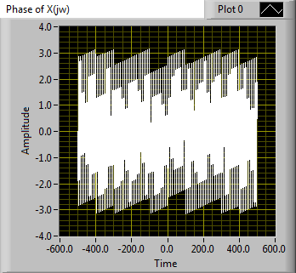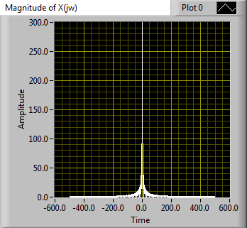

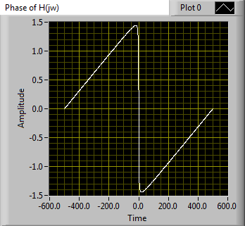

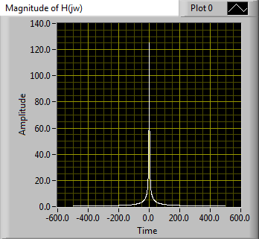

1. The code that I used to plot the phase and magnitude of Y(jw) is below along with a screenshot of the graphs that were produced by the code:

y_f1 = (-fs/2):(fs/length(xt)):(fs/2)

yFT_mag = abs(yFT)

yFT_phase = angle(yFT)

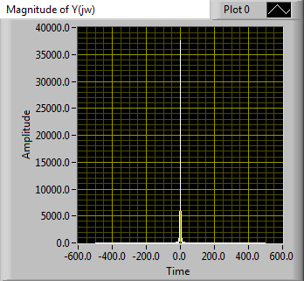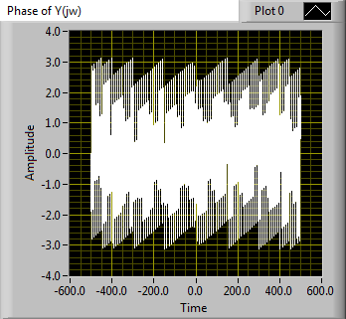

1. The code that I used to inverse Fourier Transform Y(jw) into y(t) is shown below:

yFT = xFT.*hFT

yFT_graph = fftshift(fft(yFT))

yFT_inverse = ifft(ifftshift(yFT))

1. The code that I used to plot y(t) is below along with a screenshot of a graph that was, in part because this is a merged graph, by the code:



In the fourth problem we were asked to use the shift property of the Fourier Transform to find and plot the output signal for shifted versions of the input signal due to the change in D. The phase of Y(jw) and X(jw) change when the delay changes. Another thing that changed is the beginning of the y(t) that we obtained from performing the inverse Fourier Transform of Y(jw). This is because when you do the Fourier Transform of y(t)and you have N points, but to graph it you need more than N points.